|  |
| --- |
|  |
| OrgPortal |
| Wireframes |
|  |
| **Jerry Falconer** |
| **2/11/2014** |

* 1. Home (Admin)

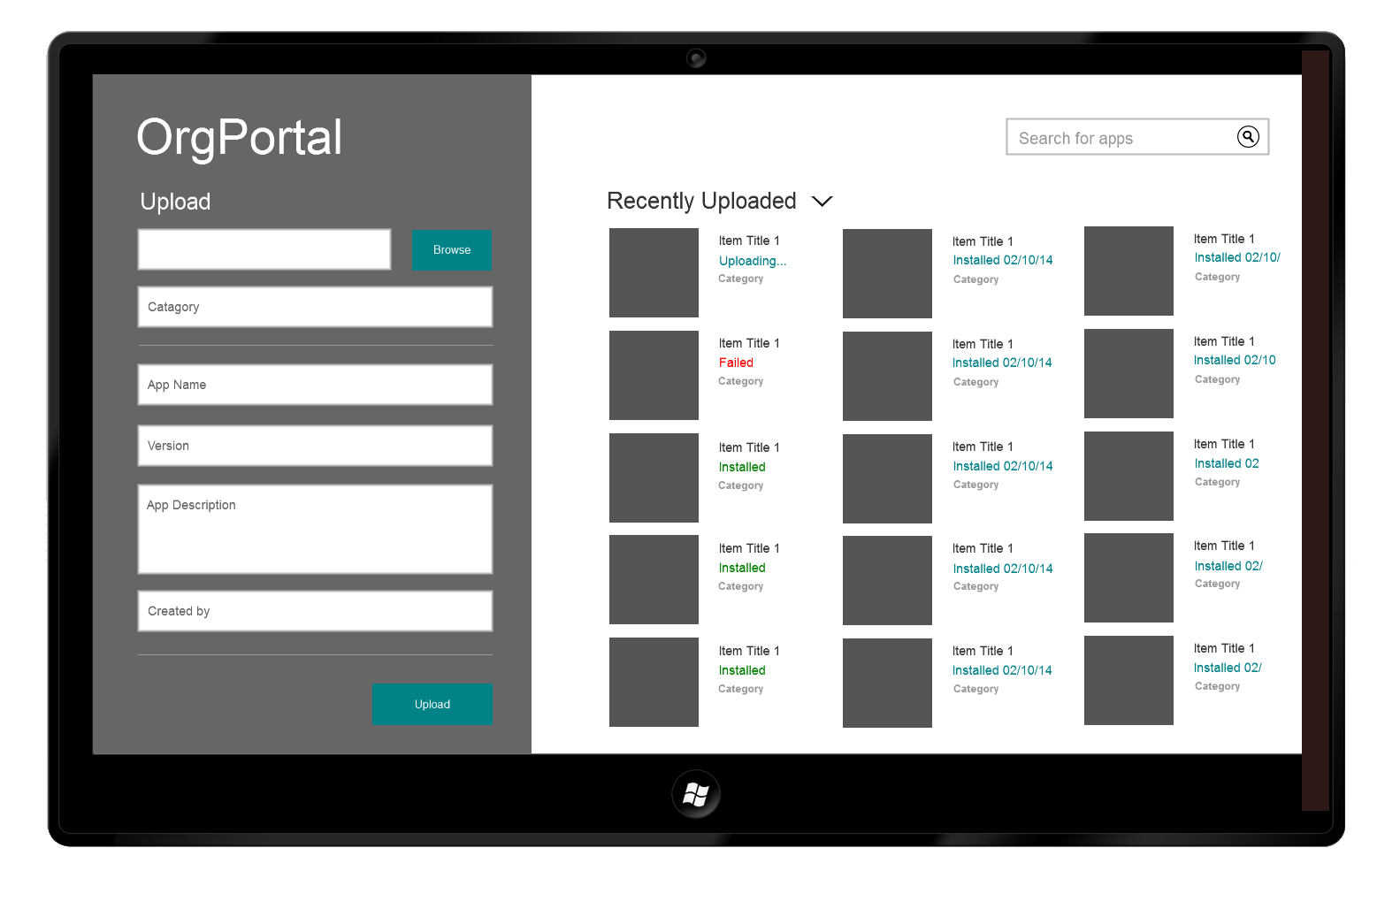

* 1. Recent Upload Menu

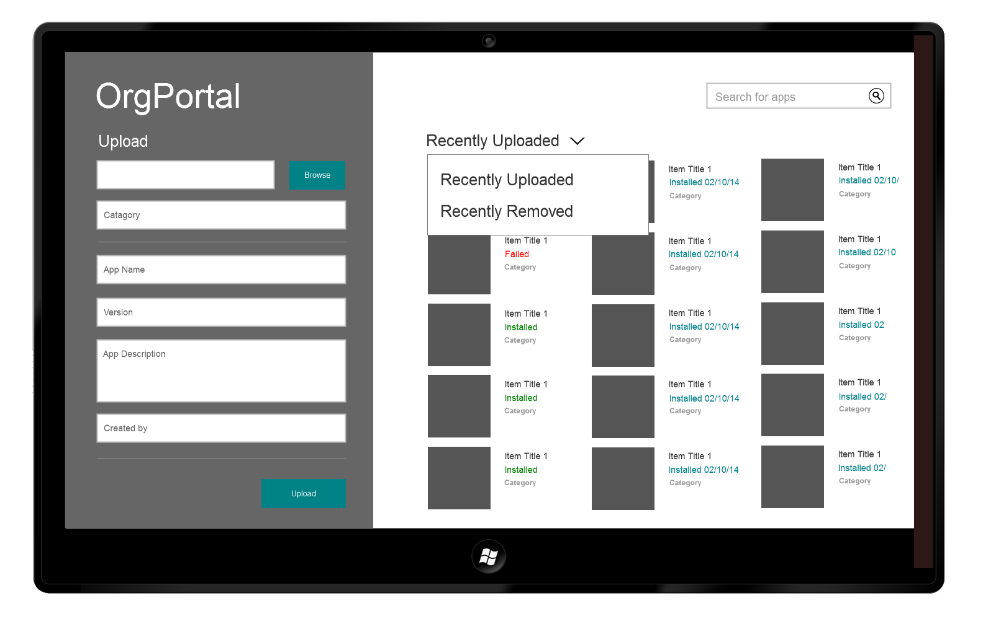

* 1. Menu (Main)

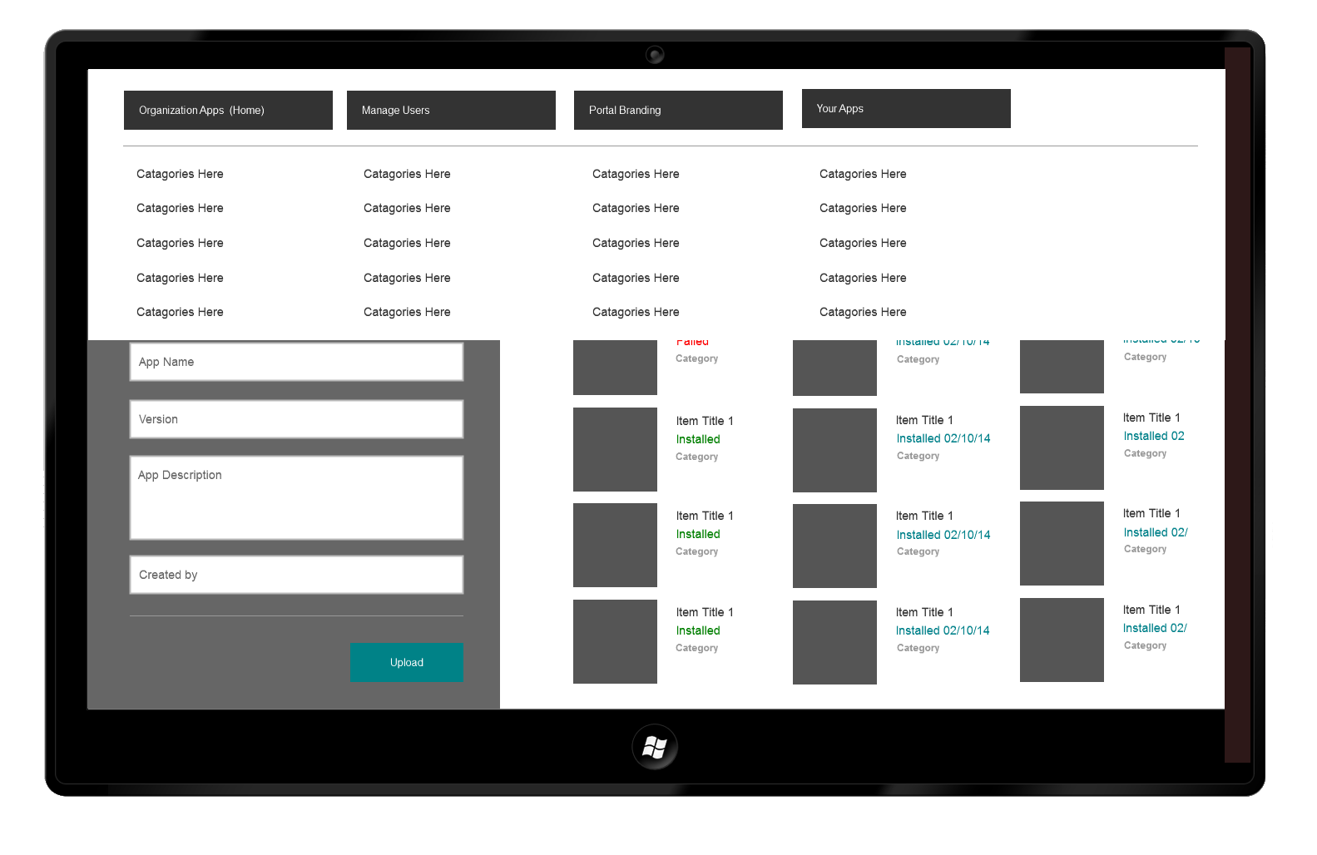

* 1. App Bar

